
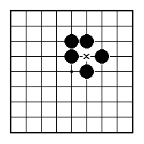
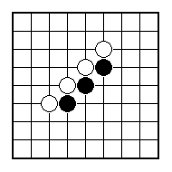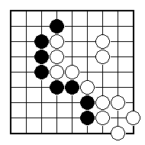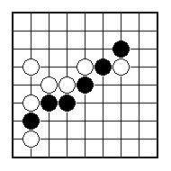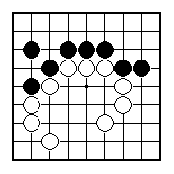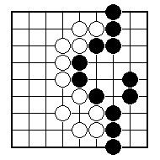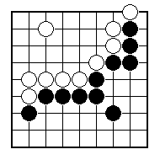
Where can Black play a double atari?

Black to play an atari that threatens another atari.

Where can White play a double atari?

Black to play an atari that threatens another atari.

How can White break into Black’s territory?

Black to play and win at least one stone.

NAME:
BRITISH GO ASSOCIATION CERTIFICATE LEVEL 2 - SHEET 6

DOUBLE ATARIS & SEQUENCES OF ATARIS

